MINUTES OF THE 33rd ANNUAL GENERAL MEETING OF THE W C G A
1st FEBRUARY 2026

VENUE / Host : Corsham CC

TIME : 10.15 am

ATTENDANCE :
G Clift (Shrewton/WGA), P Jackson (Corsham CC/WCGA), J Wilkins (Goatacre & WCGA) K Thompson (Swindon CC) M Smith (B-O-A CC & V Chair WCGA) R Saull (Grittleton CC), P Sykes Wilts Cricket Ltd , P Meadows ( Corsham CC), R Todhunter (Whitley CC), ), A Short (Biddestone CC / WCGA) ), P Jeggo (GMA), R Mosdell, (Wilts PA & WCGA), Nick Pepper Head Groundsman Somerset CCC (Guest Speaker), P Mortimer Somerset CGA, (Guest). (14 In attendance)
APOLOGISE : D Betts (Corsham CC), P Dennis (Steeple Langford CC) P Stayt (Erlestoke & Coulston CC), ), R Mansell (Devizes CC), M Mikurenda (Fonthill CC), (5no Apologise)
PREVIOUS MINUTES :
The minutes were adopted as a true record: Prop By: P Meadows & Sec. By : J Wilkins : Carried from the floor.
MATTERS ARISING :
There were no matters arising from the minutes.

Chair’s Review of 2025

Introduction

Welcome to Corsham Cricket Club for this year Annual General Meeting of the Wiltshire Cricket Grounds Association.
For those that don’t know me I am Paul Jackson, the Chair of the Association and also the Head of Grounds here at Corsham CC.
I’d like to give a special Welcome to Nick Pepper the Somerset Cricket Head Grounds Person who is going to give us a presentation about the changes he has implemented since becoming Head Grounds Person (relaying pitches, renovations e.g.) and the challenges faced during the season. I’d also like to thank Phil Jeggo, of the Grounds Management Association, who is the Regional Pitch Advisor for the South of England, for coming along and supporting us today. Phil joins most of our meetings to bring us up to date in the ECB’s latest thinking and plans for all things associated with Grounds management, plus keeping us up to speed on good practice around other county associations.
As ever, our intention today is to run through the business of the AGM as quickly as possible, to allow us as much time as possible for Nick to give his presentation and to take any questions.

Chairs Report:
Another testing year for everyone involved in preparing pitches. The lovely dry summer caused havoc for most of us, in trying to get enough moisture into the pitches and stop the strips from drying out. Depending on what irrigation is available at any particular ground, it was trying times. For those like Corsham, without a large water tank, many grounds had their hose pipes running for much of the week, trying to manage watering between the numerous fixtures we have on grounds nowadays.
Despite the difficulties, most clubs were able to produce pitches to a reasonable standard. This was reflected in the overall pitch markings, with only a few clubs needing some support and advice from the association. Baring that in mind, I’d like to thank all the grounds staff across the county for all their efforts last season, in trying to get the games on. Without the grounds staff, there’s no pitches and no Cricket.
This year the association carried out End of Season Renovations and Spiking on 23 grounds around the county. A big thank you to Richard Mosdell, Martin Bridge, David Betts and John Wilkins for getting all the work done.
The End of Season Renovations is a big part of what we deliver to clubs, but we are aware we are starting to struggle to deliver the work primarily due to people available to carry out the work and aging machinery. The Association have considered moving to Tractor mounted machinery to speed up the work and to potentially lower the manpower required to carry it out. A number of factors have caused us to move away from that at the time being, primarily due to upfront cost the equipment, transportation of the equipment and storage. We are currently considering our options on how this is delivered in the future. Richard will talk more about this as we go through the meeting.
Finally, a big thankyou to the continued support of my committee – George, Mike, Pete, Andy, Richard, and John, and again to Phil for his continued support Without their help, support and sharing of knowledge, we would not achieve anywhere near as much.

TREASURERS REPORT :
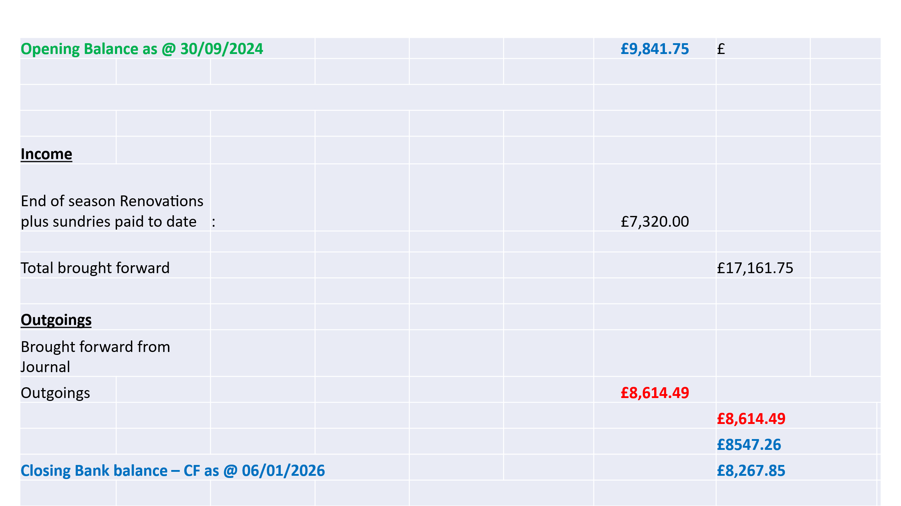
Andy Short reported that a couple of invoices since the above statement which were outstanding, have now been paid, therefore our current balance is in the region of (9 + K when banked).

Clubs are reminded for those wishing to hire the trailer for Autumn renovations 2026, to contact the WCGA Secretary / Chairman to book early for next year’s renovation work and anyone wishing to get hands on in helping deliver the renovation autumn programme please get in touch with us.

Report adopted as a True Record : Prop. By : R Saull & Sec By: P Meadows: Carried from the floor.

ELECTION OF OFFICERS :

The Chair asked the members if any member present would wish to stand for office in any of the roles listed, no one came forward, therefore it was decided by the Chair, to re elect en bloc.

Chair : P Jackson : Elected en-bloc

Vice Chair : M Smith: Elected en-bloc

Secretary : G Clift : Elected en bloc.

Treasurer : A Short : Elected en bloc

WCGA Board Representative : J Wilkins : Elected on-bloc

Proposed by : P Meadows (Corsham CC), Seconded by R Todhunter(Whitley CC), Carried from the floor.

GUEST SPEAKERS : R MOSDELL WCGA & Wilts PA
P Sykes : MD Wiltshire Cricket Ltd.
Nick Pepper Head Groundsman (Somerset CCC Taunton)

PS then took to the floor afterbay short break, to give a brief overview on the new strategy for Wiltshire of which he is currently working on, also explaining about club applications for next seasons Pitch Power Improvement Funding / surveys etc.

RM (Wilts PA) Spoke about the WCGA’s current situation, regarding EOSR and current / future manpower and the current position with regards to the aging state of our machinery equipment. As an association we are faced with a big decision in the coming months as to which way do we go as to replacing our now aged equipment and how do we deliver the EOSR service to clubs. The committee are treating this as a matter of urgency, and are hoping to be in a position to update clubs before the season commences.

Nick Pepper, Head Groundsman Somerset CCC .

Nick took to the floor and gave an excellent presentation covering:-

- The main ground & the 2nd ground at Taunton Vale
- The staff structure
- The demanding fixtures
- The pitch prep for County Champ. Games & T20 /50 one day games
- Fertilizer programme
- Renovations + Out of season maintenance works
- Showed us an insight into the mandatory pitch marking requirements etc.

Nick rounded off his presentation with a Q & A from the floor.

Full details of Nicks presentation can be accessed: (NPepper: Presentation) on our Wilts Web Site.

A O B :

Nick has kindly invited our association down to a championship match during the season, probably on day 3, GC will sort something out with nick, and circulate to members, plus also extend an invite to our Somerset colleagues.

The date for next year’s AGM will be :

7th February 2027 and the venue to be confirmed.

The AGM finally closed at : 12.10 pm

G W Clift (Hon.Sec. / Treas.) Date: 2nd February 2026

