MINUTES OF THE ANNUAL GENERAL MEETING OF THE W C G A
6th FEBRUARY 2022
VENUE : Corsham CC
TIME : 10.00 am
ATTENDANCE :
G Clift (Shrewton/WGA), P Stayt (Erlestoke & Coulston CC), M Smith (B-O- Avon CC & SWCCL, P Sykes {WC Ltd,} P Mortimer (Chairman of Somerset CGA and committee member of WEPL), P Jackson (Corsham CC/WGA), R Todhunter ( Whitly CC), P Jaggo (GMA) K Thompson & G Tompkins ( Swindon CC ), R Mosdell (Wilts PA), A Frost & G Kirtley Heytesbury & Sutt.VenyCC ), D Betts (Box CC),Tim Cowley (South Wilts CC), P Mathias (Avebury CC), Jack Colyer (Oval Groundstaff) & Tom Cowley (Assist. Hd Groundsman Ageas) Guest speakers. (18 no in attendance).
APOLOGISE :. P Dewsbury (Cricklade CC), M Gardner (Purton CC), K Little (Shrewton CC), G Gaiger (Potterne CC) G Gill (Westbury CC) M Mikurenda (Fonthill CC) ?? A Short ( Biddestone CC ), J Wilkins (Goatacre CC) , K Boulton & A Short (Biddestone CC ),R Low (Box CC), P Dennis (Steeplelangford CC.)
PREVIOUS MINUTES :
The minutes were adopted as a true record: Prop: D Betts Sec. : P Stayt Carried from the floor.
MATTERS ARISING :
There were no matters arising from the minutes.

CHAIRMANS REPORT:

Chairman’s Review of 2021/22
- A warm welcome to everyone, thank you for taking the time to join us today. In particular, our guest Speakers. We intend to get through the main elements of the AGM agenda as quickly as possible, so that we can give more time to our guest Speakers. I would also like to thank Phil Mortimer for coming along today. Phil is my opposite number For Somerset Cricket.

- We are very lucky to have to great guest speakers with us today, Pete Sykes of Wiltshire Cricket limited; Phil Jeggo of the Grounds Management Association; Tom Cowley Assistant Head Groundsmen Ageas Bowl Hants and Jack Colyer of the Oval Groundstaff. I look forward to hearing from them later in the meeting

- For the second season running Cricket was affected by Covid 19 restrictions, albeit to a much lesser degree than the previous season. Thanks to the flexibility and understanding of the various Cricket Leagues, in particular the Wiltshire County Cricket League and the West of England Premier League, much more Cricket was able to be played.

- It was good to see so much more Cricket available to people of all ages, gender, and ability. This amount of cricket could not have been achieved without the fantastic work undertaken by Grounds Staff across the county. In particular, the volunteers who give up their time and effort to enable this great game of ours to be played to the highest standard possible. I’d personally like to thank everyone for their efforts over the past season.

- I would also like to thank Pete Sykes and Wiltshire Cricket limited for putting on “Thank You” evening for ground staff in recognition of the work everyone has been doing, particularly though Covid.

- As with the previous season, many clubs found themselves facing some financial challenges. Thankfully, several schemes for Grants and/or loans were established, particularly through the ECB and Sport England, which enabled clubs to cover some of their costs. I think Pete might say a bit more about those and current schemes when he speaks.

- The Association has not been able to run many of its training courses over the past few seasons. However, we were able to run 2 “bite size” Autumn renovation course last year where we had 4 or 5 people attend each one. These seemed to be well thought of and may well form part of our normal business moving forward. I will take this opportunity to thank Fonthill Park CC and Goatacre CC for hosting the events. We hope to be able to offer more bite size training events in the future, possibly as early as March, on pre-season work. For those keen to develop their skills, the GMA offers training and development for Grounds staff including some online courses. I’m sure Phil Jeggo will say more about these later.

- The Association provided its usual Autumn renovations service again last year, with 28 Clubs taking advantage of the scheme. My thanks go to Richard Mosdell and John Wilkins for operating the trailers again.

- I would like to finish by thanking my fellow committee members for their continued help and support. They have a wealth of knowledge and experience to share, have a great network of contacts on which to draw on, and don’t mind rolling their sleeves up and getting stuck in.

- To finish, I want to say a particular “Thank You” to George Clift. He has decided to stand down from the roles of Treasurer and Secretary this year. George has been on the committee since March 1999, from the very start of the formation of the association (23 years). I believe Gordon Gill talked him into joining originally, at the inaugural meeting at Westbury. Thank you for everything you have done over the years, the support you have given the clubs and the committee, and in particular the various Chairmen. It has really been appreciated.

SECRETARIES REPORT :

The WCGA committee have continued to meet monthly, with Pete Sykes (MD Wilts Cricket Ltd.) generally via ZOOM.

The WCGA have not been able to run any short “Bite Size” courses, or offer any training to clubs throughout the year as a result of Covid-19, this also has had a major impact on the planned training programme.

We plan to roll out “Bite Size” training and the date set for the first short course has been set for the 12th March 2022 and will be held at Erlestoke CC, details will be circulated to all clubs and posted on the website. This course will cover Pre-season rolling, setting out the square, and preparation of first wicket.The dates for any further courses will be posted when agreed by committee.

The two trailers were deployed again in the autumn with a good degree of success, with more teething problems than last year and it was also nice to see a few new clubs coming on board with the renovation package on offer.
Clubs are reminded for those wishing to hire the trailer for Autumn renovations 2022, to contact the WGA Secretary to book early for next year’s renovation work .

TREASURERS REPORT :

The treasurer reported a closing balance for the year end, of £9,054.25 as at the date of 30th September 2021 a more detailed balance sheet will be posted on to the Wiltshire Cricket Ltd Groundsman’s link together with a copy of the minutes from this meeting should you wish to view. A new budget for 2022 will be compiled for approval by P Sykes and the WCGA Committee, for various strategic activities throughout 2022 / 23, at the committee’s next meeting. The current balance as at the time of this meeting stands at £3,282.99, with all invoices paid up to date.

The trailer system was sent out on hire and undertook works to 27 cricket clubs, (29 Squares), this brought in an income of £7,825.00, with outgoing transport and operator costs of £4,045.00. Repairs and servicing this year and during the renovation programme were a bit excessive £1,033.79, highlighting the need to replace certainly one of the scarifiers. John and Richard, have also completed the spiking programme in their respective area’s.

The WCGA would like to take this opportunity to say a big thank you to both John Wilkins and Richard Mosdell, and Paul Jackson, for all their hard work in delivering the programme on behalf of the WCGA.

Report Adopted as a True Record : Proposed By : A Frost, Seconded By: M Smith, : Carried from the floor.

ELECTION OF OFFICERS :

The Chairman asked the members if any member present would wish to stand for office in any of the roles listed

Chairman : P Jackson : Elected en-bloc

Vice Chairman : M Smith: Elected on-bloc

Secretary : Vacant position GC Standing down : Position not filled

Treasurer : Vacant position GC Standing down : Position not filled
Both roles to be discussed at the first committee meeting, GC to attend on a temporary basis until positions sorted to allow for smooth transition.

WGA Board Representative : J Wilkins : Elected on-bloc

CONSTITUTION : ASSOCIATION NAME CHANGE:

In line with other CGA’s it is proposed that the current name of the Association be changed from it’s current name: Wiltshire County Groundsman’s Association to: Wiltshire Cricket Grounds Association
Proposed By: P Jackson, Seconded By : K Thompson, Carried from the floor.
Mandate changes will need to be made at Nat West Bank with a copy of the AGM minutes.

GUEST SPEAKERS:

Jack Colyer: Groundstaff ( Kia Oval ) Formally Potterne CC / Gavin Jones

Tom Cowley: (Ageas) Hampshire CCC Assist.Head Groundsman. Formally South Wilts CC

PETE SYKES : MD WILTSHIRE CRICKET Ltd.

Pete talked about the recent groundsmans evening held in Devizes, which Wilts Cricket Ltd hosted as a thank you evening for all the hard work that our club groundsman undertake to enable cricket to be played. He also mentioned about the transition back into cricket during the lifting of restrictions during Covid and the more demands that are being now seemingly being placed on groundsmen with the advent of bigger fixture lists ie Pathway cricket and Girls/Ladies cricket taking off.
Pete also said that there is now evidence of a higher growth increase in new audiencesin cricket and more funding now being injected into Wilts Cricket, by way of County Grant Funding etc. and how the board are dealing with clubs applying for the grants under the three categories as outlined.

GMA : Phil Jeggo, (Regional Manager)

Phil introduced himself, his background, his role as a sports specific GMA advisor for our area and he will be dealing with cricket related issues following the GMA restructuring and gave a brief GMA update on ECB restructure, and training online.
Phil also talked about issues such as, how do we entice/get people into groundsmanship especially targeting young club members . It was generally felt that training and education were the key factors to hopefully achieve this goal. Currently all 3no cricket training modules are on line on the GMA website. (see below links)
Phil also mentioned the need for County PA’s to be more involved and the need for training to be set up for them this has been long overdue. From April it is proposed that a new self assessment APP for your mobile phone will be launched and be available.

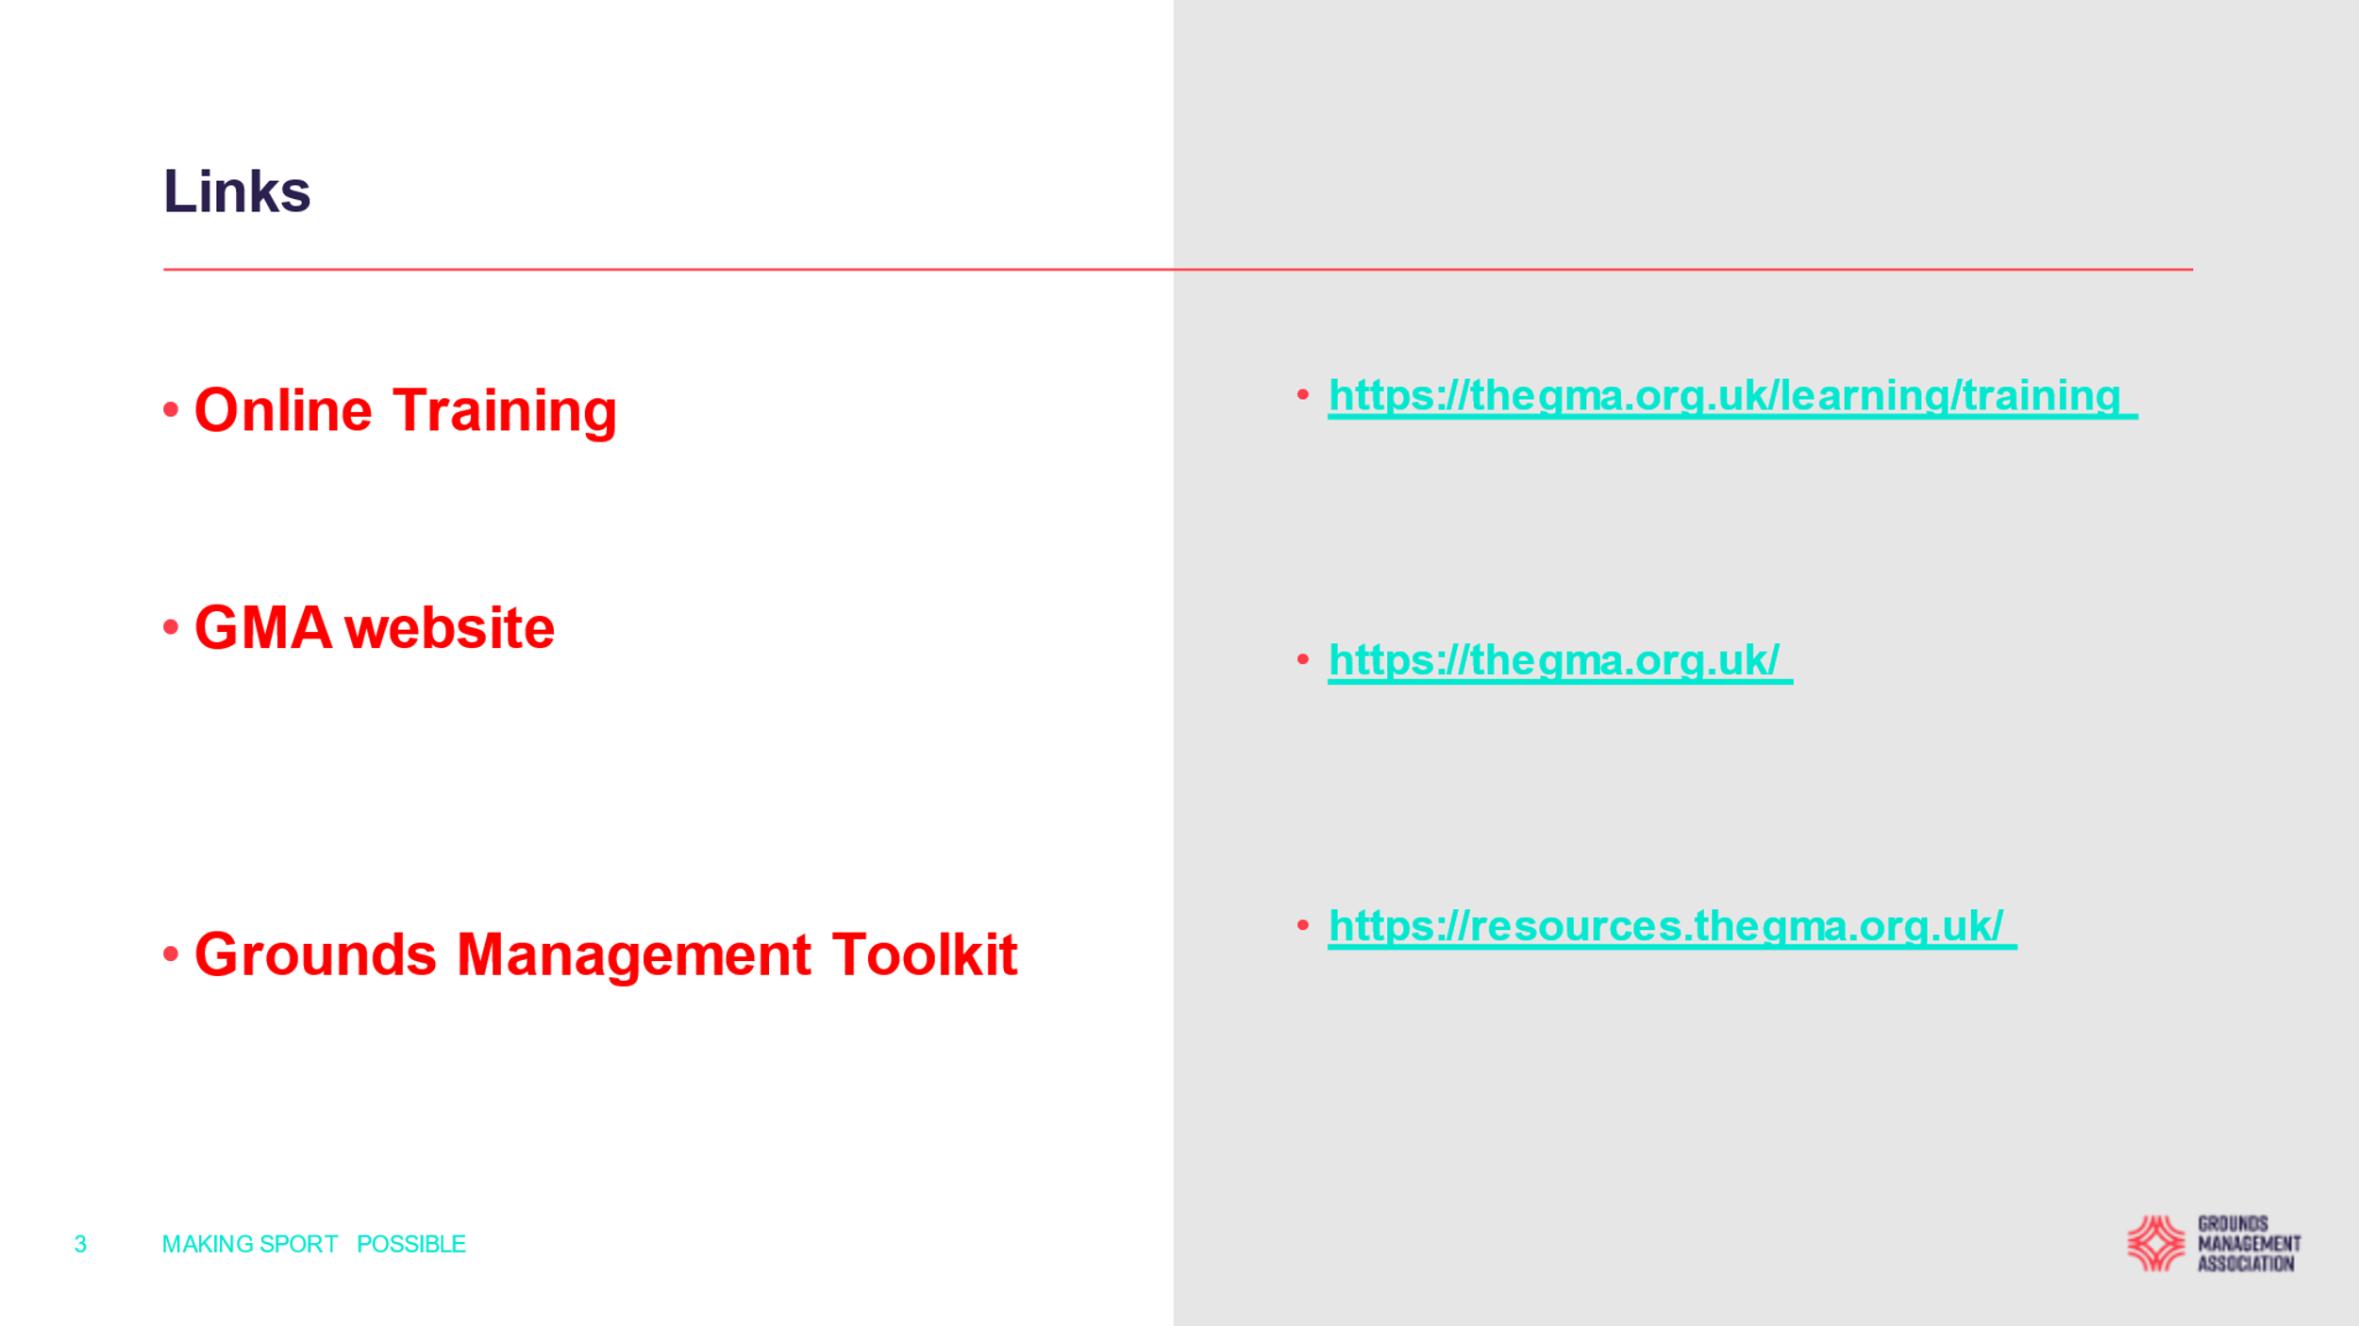

A O B :

The date for next year’s AGM will be the 5th February 2023 and the venue at Shrewton CC to be confirmed.

The AGM finally closed at : 10.45 am
Then our two guest speakers took to the floor and gave a very informative insight on moving from grassroots into the pro game and elements they carry out when preparing wickets, they also dealt with the care of Hybrid wickets. Our huge thanks go out to both Jack and Tom for giving up their time to attend our meeting, both having progressed from Wiltshire grassroots cricket into the world of professional cricket congratulations to them both.

A big thanks to Pete and Phil and Phil Mortimer (Somerset CGA Chairman) for taking time out to attend and support our AGM.

G W Clift (Hon.Sec. / Treas.) Date: 7th February 2022

