MINUTES OF THE ANNUAL GENERAL MEETING OF THE W C G A
7th FEBRUARY 2021
VENUE : ZOOM VIDEO CONFERENCE
TIME : 10.30 am
ATTENDANCE :
G Clift (Shrewton/WGA), P Stayt (Erlestoke & Coulston CC), M Butler (Calne CC), J Wilkins (Goatacre CC), M Smith (B-O- Avon CC & SWCCL, P Sykes {WC Ltd,} P Mortimer (Chairman of Somerset CGA and committee member of WEPL), P Jackson (Corsham CC/WGA), P Dennis (Steeple Langford CC, K Boulton & A Short (Biddestone CC ), S Johnson (GMA & Guest Speaker), C Warren & A Brown ( Beehive CC),R Todhunter ( Whitly CC), M Mikurenda (Fonthill CC) (16 no in attendance).
APOLOGISE :. R Mosdell WCGA PA , G Gill Westbury CC, M Gardner, & C Wright (Purton CC)
PREVIOUS MINUTES :
The minutes were adopted as a true record: Prop: P Stayt (Erlestoke CC) Sec. M Butler (Calne CC): Carried from the floor.
MATTERS ARISING :
There were no matters arising from the minutes.

CHAIRMANS REPORT

Chairman’s Review of 2020/21

- Welcome to everyone, thank you for taking the time to join us on Zoom

- Please could I ask that everyone remains on MUTE during the proceedings unless they wish to say something. This enables everyone to hear what is being said without any background noise interfering.

- This, my first year as Chairman has turned out to be a very strange year. It started off with a very wet winter, not really stopping raining until late February/early March. We groundsmen were struggling to get onto our grounds and carry out the essential work necessary to enable play. Then, along came covid-19 and the disruption that has brought to the lives of everyone. Some groundsmen were still able to get to their grounds during the early lockdown and prepare for Cricket, but others were not so fortunate, some clubs really struggled to get grounds ready, particularly if their grounds were maintained by local authorities. At least the Spring and Summer weather was good enabling things to be done and grounds made playable.

- Thanks to the efforts of the various Cricket Leagues, in particular WCCL and WEPL, and the flexibility of the clubs, some competitive Cricket was able to take place from the end of July, with the season being extended, for many clubs, out to the end of September. This meant that for some groundsmen, there were a lot of matches crammed into 10 week period, that was a lot of pressure and without the groundsmen putting in the time and effort, this could not have happened. Well done to everyone.

- Many clubs found themselves facing financial difficulty, last season, with little or no income being generated in the early season and only limited income, once Cricket could start. Thankfully, a number of schemes for Grants and/or loans were established, particularly through the ECB and Sport England, which enabled clubs to cover a lot of their running costs. Without this support I believe a number of clubs would not have survived. My thanks go out to Pete Sykes, of the Wiltshire Cricket Board, for keeping clubs aware of the support that was available and helping them work their way through the various application processes. Fr

- From an Association viewpoint, the financial support, for End of Season Renovations, was particularly important, as it enabled clubs to get this, all important, work done. Although the renovations started much later last year, we were able to get the county trailers around to most of the clubs before the weather turned. My thanks go to Richard and John, for fitting in all the clubs requiring our support. It was a great effort.

- This year, like everyone else, the Association has been prevented from operating in our usual way. There were no pitch markings to look at, which guide us to clubs who might be in need of support, nor were we able to support you groundmens with the various Training and Workshop/forum events that we would normally run. We see these events as an important part of our role. The continued training and developing of all groundsmen, ensuring we are all up to speed with the latest development and thinking in grounds maintenance, is essential if we are to continue to improve the quality of pitches, the standard of cricket played and the enjoyment of everyone involved in our great game. Hopefully, we will be able to start these events again, via Zoom if necessary and appropriate, later this year. We already intend to put together a few short videos, devised by our County Pitch Advisor, Richard Mosdell, providing some simply hint, tips and techniques for maintaining the square. Once filmed, these will be available to all on the Wiltshire Cricket Website. Pete Sykes will let you know when they are available and where to find them on the website

- Some of you may have been able to access some training through the internet, last year. Whilst I had time on my hands, icame across the level 1 Cricket Grounds Maintenance Course, provided by the Grounds Management Association. I decided to give it a go. I found this to be a good informative training course, covering a wide range of ground maintenance topics and activities. Whilst level 1 was possibly not necessarily intended for the more experienced groundsmen, I personally learnt some new stuff and, perhaps more importantly, got some good reminders of things that I had forgotten about or take for granted. I think Simon and Pete will touch a bit more on these training opportunities later in the meeting.

- I am sure we are all hoping that Cricket will be able to be played a bit more normality this season, particularly with the vaccine being rolled out and having the lessons learned form playing with restrictions last season. Once the weather improves and we can get out on our grounds. I for one, cannot wait to get on the square and start preparing it for the forthcoming season. If anyone needs any support, advice, or guidance, on maintenance issue, please do not hesitate to contact us so that we can help where we can.

- I would like to finish by thanking my fellow committee members for their continued help and support. They are a keen bunch that do well to keep me on track! They have a wealth of knowledge and experience to share, have a great network of contacts on which to draw on, and don’t mind rolling their sleeves up and getting stuck in. So thanks to George, Mike, Pete, John and Richard, for all your help guys.

- Thank also, to everyone Zooming in today and for the time you give to cricket as volunteers. Thank you.

SECRETARIES REPORT :

The WCGA committee has continued to meet on a monthly basis with Pete Sykes (MD Wilts Cricket Ltd.) generally via ZOOM, to continue to develop the roles of the WCGA and along with Mike Smith Wilts CL and committee members, to monitor club concerns and issues and try to give guidance to clubs on on the ever changing update’s cascading down, from the Government and the ECB regarding Covid-19 issues.

The WCGA have not been able to run any short “Bite Size” courses, or offer any training to clubs this year and also, as a result of Covid-19, this also has had a major impact on the length of cricket played.

The dates for any Autumn courses will have to be arranged as and when or if the Covid rules allow us to in 2021. Dates as and when, will be posted on the Wilts Cricket Web Site in due course, together with newsletters to all clubs.

The two trailers were deployed again in the autumn with a good degree of success, with very minimal teething problems and it was nice to see a few new clubs (5no) coming on board with the renovation package on offer.
Clubs are reminded for those wishing to hire the trailer for Autumn renovations 2021, to contact the WGA Secretary G Clift Tel: 01380 813928 to book early for next year’s renovation work

TREASURERS REPORT :

The treasurer reported a closing balance for the year end, of £5678.06 as at the date of 30th September 2020 the balance sheet will be posted on to the Wiltshire Cricket Ltd Groundsman’s link together with a copy of the minutes from this meeting should you wish to view. A new budget for 2021 will be compiled for approval by the MD (P Sykes and the WCGA Committee) for various strategic activities throughout 2021 / 22, at the committee’s next meeting. The current balance as at the time of this meeting stands at £2007.46, (excluding membership fee’s).

The trailer system was sent out on hire to clubs and undertook works to 21 cricket clubs, (22 Squares), this brought in an income of £5575.00, with outgoing transport and operator costs of £3,960.00. Repairs during the renovation programme were minimal this year, just a couple of minor teething issues. John and Richard, also completed the spiking programme in their respective area’s.

The WCGA would like to take this opportunity to say a big thank you to both John Wilkins and Richard Mosdell, and Paul Jackson, for all their hard work in delivering the programme on behalf of the WCGA.

Report Adopted as a True Record : Proposed By :P Stayt (Erlestoke CC) Seconded By: M Smith (B-On-Avon CC) : Carried from the floor.

ELECTION OF OFFICERS :

The Chairman asked if any person from the floor wished to stand for election for any role listed below, no one offered to stand, and all current officers said that they would be prepared to stand again for election, therefore the Chairman asked the floor to vote en-bloc for the current serving officers.
To re-elect all current officers was proposed by : R Todhunter (Whitley CC) seconded by : P Stayt (Erlestoke CC) decision : Carried from the floor.

Chairman : P Jackson :

Vice Chairman : M Smith:

Secretary : G Clift

Treasurer : G Clift

WGA Board Representative : J Wilkins :

GUEST SPEAKERS:

PETE SYKES : MD WILTSHIRE CRICKET Ltd.

Pete Sykes representing Wiltshire Cricket Ltd, took to the floor, and gave a brief talk / update to all
Regarding thoughts on the projected start of the grassroots cricket season. He said that everyone should plan for a normal seasonal start and work towards this (weather permitting) and be prepared to review, should the need arise.

PS also spoke about grant schemes / updates, to date, 23 clubs have benefited by some £53k so far.

GMA : SIMON JOHNSON, (Regional Manager)

Simon gave a brief GMA update on ECB restructure, up and coming trade shows etc. and training online.

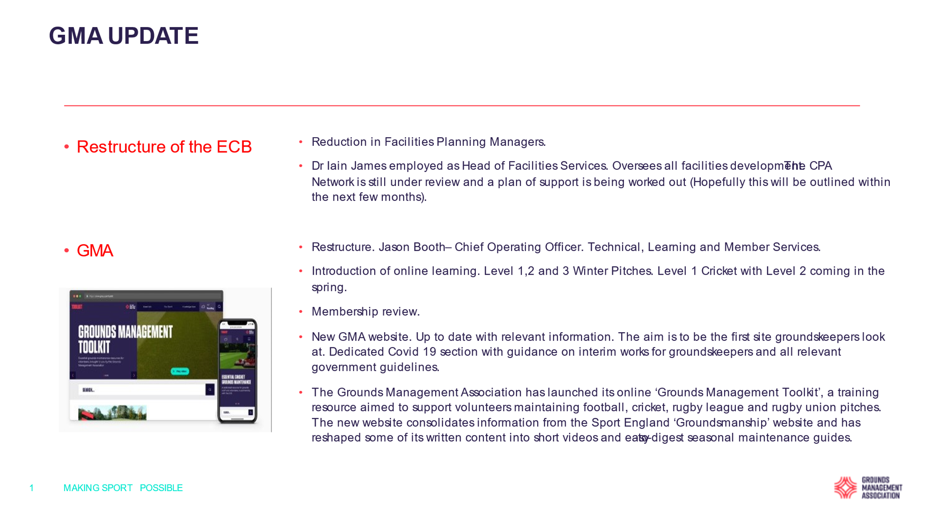
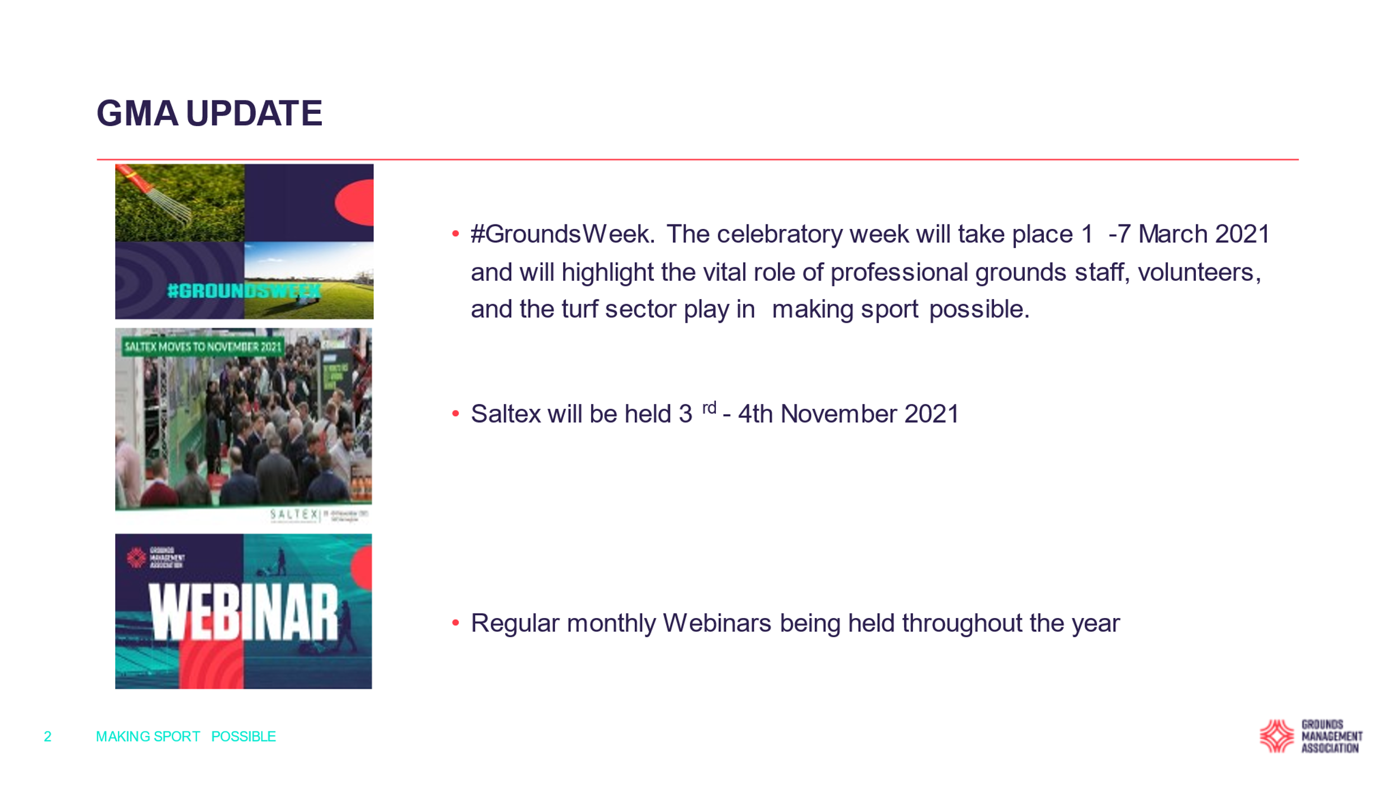
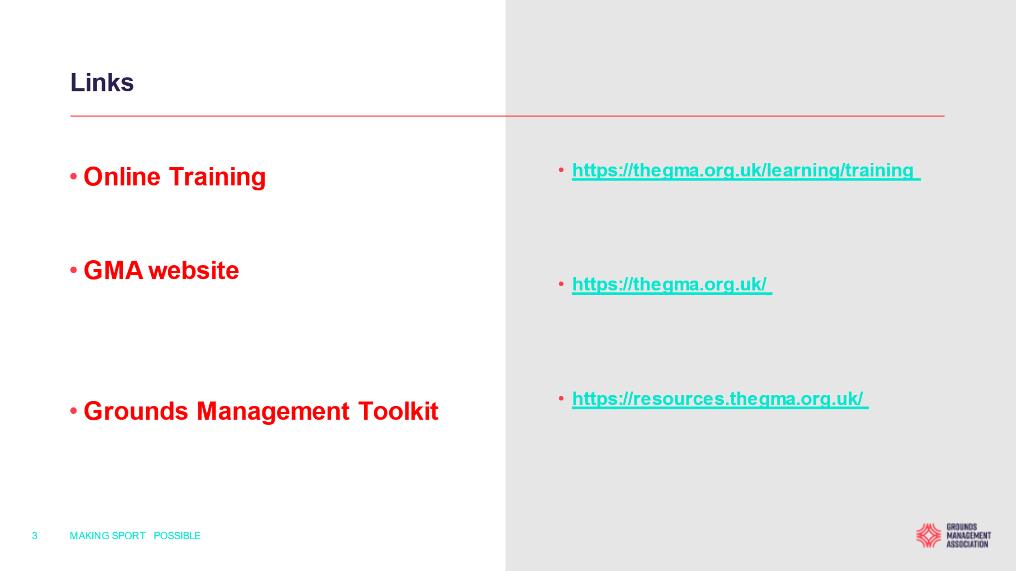
PS (P Stayt) asked SJ if there was anything on the market to treat cricket squares for worms, as his club are currently using Purity and he has heard of shortage of supplies.
MS mentioned that our Wilts PA uses Brugaurd and claims that it is better than Purity. SJ said he will check the product out and get back to us with an update.

A O B :

P Dennis asked P Sykes if Wilts Cricket Ltd had decided on the fixtures for the County teams yet. PS responded by saying that fixtures have not yet been agreed with other counties yet and that the process is ongoing. He hopes to be able to be in a position to speak to clubs by the end of February 2021.

A question arose from MS regarding as to whether or not football would resume at grassroots if restrictions are lifted and would this impact on clubs which ground share with cricket.
SJ (GMA) said that he was pretty sure that football will not be completed at grassroots level, but if he is notified of anything different, then he will come back to us in due course.

The date for next year’s AGM will be the 6th February 2022 and the venue to be confirmed.

George Clift told members that the WCGA would try to arrange a day trip to Lords for the coming season and will contact Karl McDermott to sort a date and then send out a newsletter to all for invitations to the event.

The AGM finally closed at : 11.40am

G W Clift (Hon.Sec. / Treas.) Date: 7th February 2021

